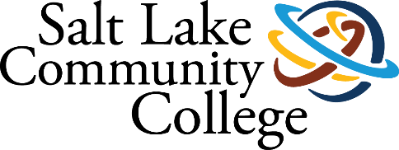 | THAYNE CENTER
2019-2020 ANNUAL ASSESSMENT
SUMMARY OF RESULTS

Project (Assessment) Title: Thayne Center Annual Report

College-wide Strategic Goal: Completion; Transfer; Equity; Sustainability

Assessment Overview: Each program reporting findings

Methodology (Plan/Method): mixed methods

Timeline: 2019-2020 academic year

Results/Findings: The Thayne Center serves students in several beneficial ways and will benefit from undergoing program review in 2020-2021 to develop a cohesive approach to contributing to the college mission.

Action Plan (Use of Results/Improvements/Call to Action): program review 2020 will support intentional alignment of strategic plan

Other Notes

